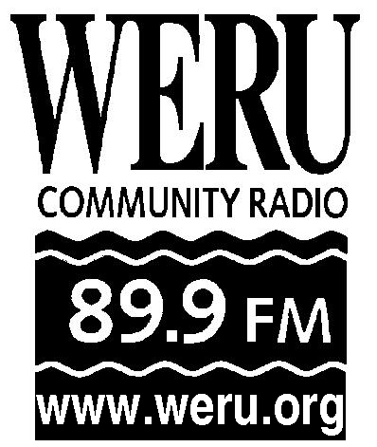
P.O. Box 170
1186 Acadia Highway
East Orland, ME 04431
(207) 469-6600
info@weru.org

Writing a Press Release
A Guide for WERU Staff and Volunteers

1. What is a press release?
A press release, also known as a news release, is simply a written statement to the media. They can announce a range of news items: scheduled events, personnel promotions, awards, new products and services, sales accomplishments, etc. They can also be used in generating a feature story. Reporters are more likely to consider a story idea if they first receive a release. It is a fundamental tool of PR work, one that anyone who's willing to use the proper format can use. (Description from the website http://www.wikihow.com/Write-a-Press-Release).

2. Subject line (if sending in an email).
Be sure that the subject line for a press release email contains identifying information for WERU. All words should be capitalized.

3. Contact Information.
The very top left hand corner of the press release should read “For Immediate Release” followed by a name, phone number and email of the contact person.

4. Headline.
The headline should be concise. The first letter should be capitalized, but not every word. It should be in bold and in a slightly larger font than the rest of the document. The headline should grab the reader. Use the keywords from the press release.

5. Date Place and Time
In a column on the left list the date, place and time for the event.

6. Body.
The information in a press release should be written as you want it to appear in a news story. Use concise language and stick to the most important parts that you want covered. The first sentence should also grab the reader and should restate the information given in the headline in a new way. The first paragraph should summarize the press release. Further paragraphs should elaborate. Use clear and simple language. Keep the paragraphs short.
Communicate the who, what, where, when, why and how of your story. Why is this news? Make sure all information describing WERU is clear and accurate. Include more contact information for WERU including website, 88.9FM and 99.9FM Bangor and phone. Restate the contact information of the person sending the press release.
Always end a press release with three centered ### pound symbols just under the last line of the release. This is a journalistic standard.

7. Email and follow up.
If possible, email the press release directly to journalists that might cover the issue or event. Otherwise send to newsrooms and news directors. Make follow up calls to confirm that news sources received the press release.

8. See sample press release below.

Subject line: WERU Presents “A Short Distance Love Affair”

For Immediate Release
Contact: Meaghan LaSala
207-469-6600
meaghan@weru.org

WERU Community Radio presents live broadcast Valentine’s dance party to celebrate new Bangor signal 99.9 FM

Friday, February 11
8PM - Midnight
The Big Easy at the Charles Inn
West Market Square, Bangor

Bangor, ME-- On Friday, February 11th, WERU Community Radio is throwing a live broadcast dance party to celebrate as we prepare to launch our new signal 99.9 FM in Greater Bangor. WERU music programmers Magnus and DG Paradise will be spinning Hip Hop, Dub, Electro, Funk, Reggae, and other Eclectic Esoterica. All ages are encouraged to attend. Donations will be accepted to support WERU.

“For many years we’ve had a goal of providing the northern part of our broadcast area with better reception,” said Matt Murphy, General Manager of the station. “We will soon be broadcasting at 99.9 in the Bangor area. We now have FCC authorization for the new frequency and will get it on the air as soon as possible, hopefully by spring if not sooner.”

WERU is a listener-supported, volunteer-powered community radio station, known for eclectic music and a commitment to provide access to the airwaves for those not fully served by other broadcast media. Meaghan LaSala is working with WERU as an Americorps VISTA volunteer to help WERU reach out to its new listeners. “This party will be a great way to let folks know about the new signal,” she said. “People can come shake off the February cold, and meet some of our volunteer programmers. It’s going to be a lot of fun!”

Those who cannot attend the event can listen live from 8PM - 10PM on WERU 89.9FM or by streaming at www.weru.org. For more information contact Meaghan LaSala at 469-6600, or meaghan@weru.org.

###

